**ASSIGNMENT 02**

FINAL SUBMISSION BY:

RICHARD DUONG & DONNA BACTOL

PROFESSOR SIJU PHILIP

CST5215 Intro to Database LAB

SECTION 343

DUE DATE: 12 DEC 2021

# Introduction / Abstract (UPDATED)

Target would like to make another attempt in expanding their business into Canada. A few stores across Canada are preparing to open for business by hiring new employees. To record-keep efficiently, a Target employee-based database was created. The database includes details such as the employee’s name, a few confidential (but necessary) employee information, their store location, and other store operative data (no inventory/products information included).

# Tables & Attributes (UPDATED):

* **EMPLOYEE** table includes:
* Emp_ID
* Name
* Activity Status (still employed but it is indicated as false if they are on leave or vacation)
* Job ID
* Store ID
* Start Date
* **PERSON** table includes:
* Name
* Age
* Employment application approved/declined
* Phone Number
* **JOB** table includes:
* Job ID
* Job Title
* Department ID
* Wage
* **DEPARTMENT** table includes:
* Department ID
* Department Name
* **STORE** table includes:
* Store ID
* District ID
* Address
* City
* Province
* Postal Code
* **Province** table includes:
* Province Code
* Province Name
* **District** table includes:
* District ID
* District Name

# Business Rules (UPDATED):

* An employee must have a name.
* All employees must have an ID.
* All employees must have a start date.
* All employees must be assigned to a job.
* All employees must be assigned to a specific store.
* Job ID have at least 1 entry.
* There must be a job title for each job ID.
* Each job must have a starting wage above $15.
* All jobs must be under a specific department.
* All stores have departments, so there must be at least 1.
* All departments must have a name.
* Every store must have an assigned ID
* Every single store must be assigned to a district.
* Person must have an age that is 15 years and older.
* Person must have employment status
* Person must have a phone number
* Employee must be listed as either active or inactive
* All districts must have an ID.

# Initial / Logical ER Diagram(s)

Some changes in business rules, entities, and attributes.

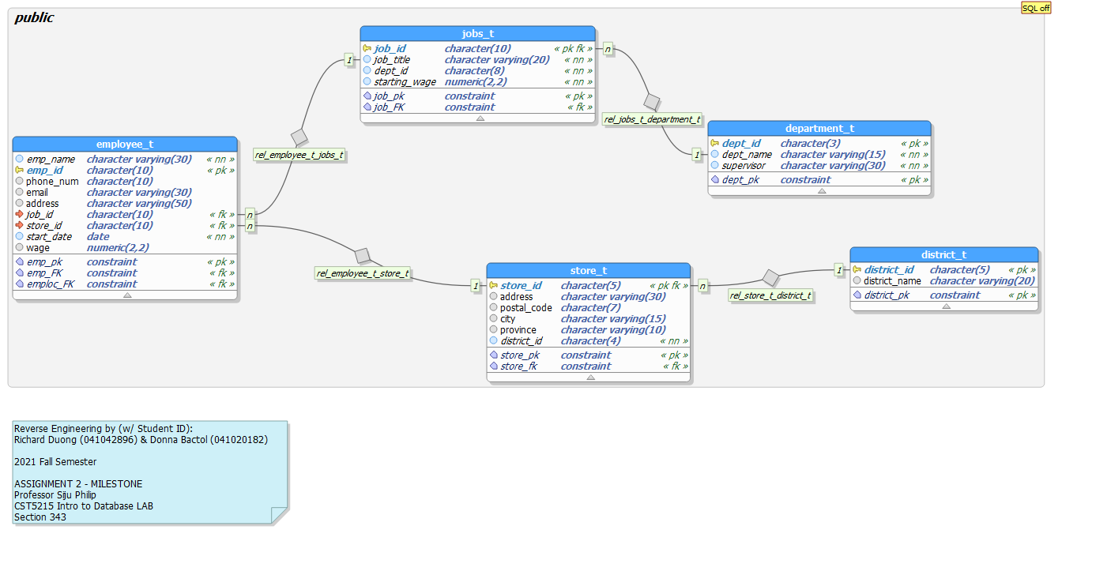

Figure - Initial / Logical ERD for Milestone

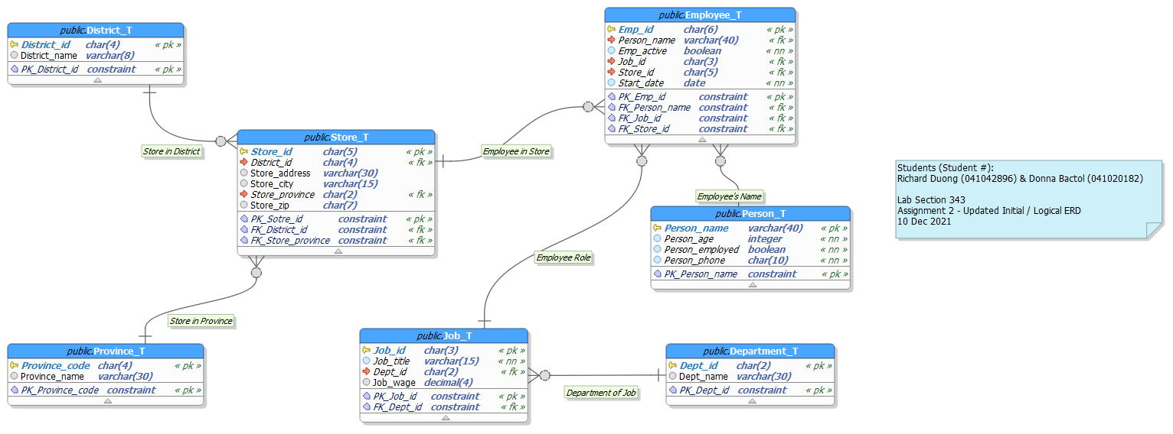

Figure - Updated Initial / Logical ERD

# Metadata

|  |  |  |  |  |
| --- | --- | --- | --- | --- |
| **Name** | **Data Type** | **Length** | **Description** | **Source** |
| district_id | character | 4 | ID given to district | Assigned by Target |
| district_name | character varying | 8 | Name of the district | Assigned by Target |
| province_code | character | 2 | Province name abbreviated | Determined by location |
| province_name | character varying | 30 | Name of Province | Determined by location |
| dept_id | character | 2 | ID given to specified department | Assigned by Target |
| dept_name | character varying | 30 | Name of the department | Assigned by Target |
| person_name | character varying | 40 | Name of the person (applicant or employee name) | Entered by user |
| person_age | integer | -- | Age of the person | Entered by user |
| person_employed | boolean | -- | Status of the person (Applicant or successfully employed by Target) | Entered by user |
| person_phone | character | 10 | Phone number of the person | Entered by user |
| job_id | character | 3 | ID given to specified job | Assigned by Target |
| job_title | character varying | 15 | The title of the job | Assigned by Target |
| dept_id | character | 2 | ID given to the department | Assigned by Target |
| job_wage | numeric | -- | Hourly wage for specific job | Assigned by Target |
| store_id | character | 5 | ID given to a specified store | Assigned by Target |
| district_id | character | 4 | ID given to a specified district | Assigned by Target |
| store_address | character varying | 30 | Address of the store | Determined by location |
| store_city | character varying | 15 | City the store is in | Determined by location |
| store_province | character | 2 | Province the store is in | Determined by location |
| store_zip | character | 7 | Postal code of store | Determined by location |
| emp_id | character | 6 | ID given to a specified employee | Assigned by Target |
| person_name | character varying | 40 | Name of employee | Entered by user |
| emp_active | boolean | -- | Employee currently on schedule | Entered by user |
| job_id | character | 3 | ID given to specified job | Assigned by Target |
| store_id | character | 5 | ID given to specified store | Assigned by Target |
| start_date | date | -- | Hire date of an employee | Entered by user |

# Reverse Engineer ERD

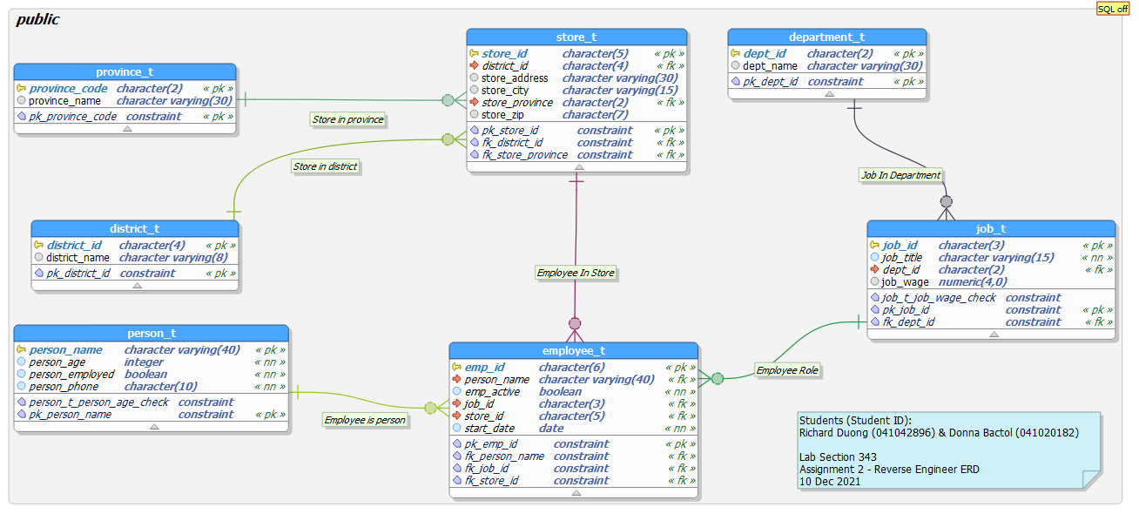

Figure - ERD obtained through Reverse Engineering